**Is your country making the most out of the EU’s bill of rights?**

Rights areas:

* [Support for human rights systems and defenders](https://fra.europa.eu/en/taxonomy/term/989)

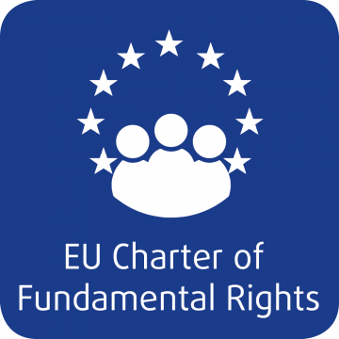

The EU’s Charter of Fundamental Rights is one’s the world’s most modern and comprehensive legally–binding human rights documents. Many EU Member States do not yet make full use of its potential.

**Publication**

[**The EU Charter of Fundamental Rights - Use and added value in EU Member States**](https://fra.europa.eu/node/36311)

To raise awareness of the Charter, the EU Agency for Fundamental Rights is releasing a series of [country sheets with examples of the Charter’s use](https://fra.europa.eu/en/publication/2019/eu-charter-country-sheets), highlighting how it adds value.

The EU’s Charter of Fundamental Rights is the EU’s very own bill of human rights. It protects the rights of everyone in the EU, whether they are EU citizens or not. This year marks 10 years since it entered into force alongside the EU’s Lisbon Treaty.

Member States have a duty to respect the rights guaranteed by the Charter. They must observe the principles of the Charter whenever they are acting within the scope of binding EU law.

They also have a duty to promote the Charter. To help in these efforts, FRA has produced country sheets for each EU Member State.

Each sheet gives examples of how Member States are actually using the Charter, when drafting policies or laws, or in their courtrooms.

The sheets also describe the Charter’s added value, illustrating which rights are covered, as well as which of the rights in the Charter are covered, or not, by national constitutions.

There are also links for further information for readers to find out more about the Charter. This includes the agency’s recent [handbook on applying the Charter in law and policymaking](https://fra.europa.eu/en/publication/2018/national-guidance-application-eu-charter). It explains when national authorities are required to apply the Charter and when not.